You will receive a phone call from us to book your appointment within 3-5 business days of you returning your form.
Patient Information:
Name:
Medicare Number:
Date of Birth:
Address:
Contact Number: | Mobile:  Home:
Email:
Gender:
Eligibility Criteria –  Please circle | - Age 60 or over  - Chronic Medical Condition – please provide further detail  __________________________  __________________________  __________________________  - Critical Worker – please provide further detail  __________________________  __________________________
Please note you may need to provide proof of your eligibility in the form of ID showing your date of birth or medical correspondence showing evidence of your health condition.
Please answer the following (continues on the next page)
YES | NO
 |  | Do you have any serious allergies, particularly anaphylaxis, to anything?
 |  | Have you had an allergic reaction after being vaccinated before?
 |  | Do you have a mast cell disorder?
 |  | Have you had COVID-19 before?
 |  | Do you have a bleeding disorder?
 |  | Do you take any Warfarin to thin your blood? (An anticoagulant therapy)?
 |  | Do you have a weakened immune system? (Immunocompromised)?
 |  | Are you pregnant or do you think you might be pregnant?
 |  | Are you breastfeeding?
 |  | Have you been sick with a cough, sore throat, fever or are feeling sick in another way?
 |  | Have you had a COVID-19 Vaccination before?
 |  | Have you received any other vaccination in the last 14 days?
 |  | Do you have a history of Cerebral Venous Sinus Thrombosis or Heparin induced Thrombocytopenia?
If you have answered YES to any of the above you may need to consult with one of our doctors prior to booking for the COVID-19 vaccine. Please return this form to Andrew Place Clinic ASAP. You will then be contacted by one of our staff to make an appointment for your vaccine.
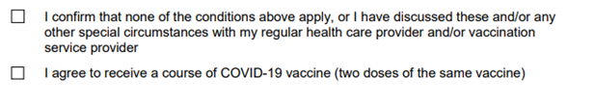
Consent to receive COVID-19 vaccine

Patients Name:
Signature:
Date:
PLEASE RETURN YOUR FORM TO: covidvaccines@andrewplaceclinic.com.au

